

School of Future Tech
CASE STUDY

LocalKart – Hyperlocal Marketplace

Rima Maji

(150096725215)

HTML 5 | CSS 3 | JavaScript

School of  Future Tech |  | 
B.Tech – LocalKart Hyperlocal Marketplace
————————————————————————————————————————————————————————————

1. WEBSITE DETAILS

Title of the Website:
LocalKart – Hyperlocal Marketplace

Purpose of the Website:
The purpose of this website is to demonstrate the design and development of a hyperlocal marketplace using HTML 5 semantic elements, CSS 3 styling and responsive layout, and JavaScript DOM manipulation to connect nearby customers with local shops through an 8-page web application.

Target Users:
- Students
- Beginners in Web Development
- Local Shop Owners and Sellers
- Customers looking for hyperlocal online shopping
- Educational Institutions

Tools Used:
- HTML 5
- CSS 3
- JavaScript (ES6+)
- Bootstrap 5.3
- Node.js + Express
- Text Editor (VS Code / Notepad)
- Web Browser (Chrome / Edge / Firefox)

Key Features:
- Semantic HTML structure across all 8 pages
- SEO-friendly meta tags and viewport settings
- Responsive CSS layout using Flexbox and Grid
- Pincode-based delivery availability checker
- Real-time shop search, rating, and delivery-type filtering
- 62-product catalogue with localStorage cart and live grand total
- Checkout form with payment toggle (Cash / UPI / Card)
- Seller registration connected to Node.js + Express backend

School of  Future Tech |  | 
B.Tech – LocalKart Hyperlocal Marketplace
————————————————————————————————————————————————————————————
2. TAG DEFINITIONS USED IN THE WEBPAGE
2.1 Basic Structure Tags

Tag | Definition
<!DOCTYPE> | Declares the document type; tells the browser this is an HTML5 document.
<html> | Root element of the HTML page; wraps the entire document content.
<head> | Contains metadata — title, charset, viewport, and external CSS/JS links.
<meta> | Provides metadata such as character set (UTF-8) and responsive viewport.
<title> | Sets the page title shown in the browser tab.
<link> | Links external resources — Bootstrap CSS and custom style.css.
<script> | Embeds or references external JavaScript files such as script.js.

2.2 Semantic Tags

Tag | Definition
<header> | Defines the top section of the page, containing the navbar and logo.
<nav> | Represents a block of navigation links shared across all 8 pages.
<section> | Defines a thematic content group — hero, shops, products, contact.
<article> | Represents self-contained content such as individual product or shop cards.
<aside> | Contains content tangentially related to the main content area.
<main> | Represents the dominant content of the document body.
<footer> | Defines the bottom section with copyright text.

School of  Future Tech |  | 
B.Tech – LocalKart Hyperlocal Marketplace
————————————————————————————————————————————————————————————

2.3 Multimedia Tags

Tag | Definition
<video> | Embeds looping background videos on Home, Shops, and Pricing pages using autoplay and muted attributes.
<source> | Specifies the media file path inside a <video> element (supports .mp4 format).
<img> | Embeds product images, the LocalKart logo icon, and decorative images across all pages.
<figure> | Wraps self-contained media (product images) with optional <figcaption> for accessibility.

School of  Future Tech |  | 
B.Tech – LocalKart Hyperlocal Marketplace
————————————————————————————————————————————————————————————
3. SCREENSHOTS
3.1 Landing Page (index.html)

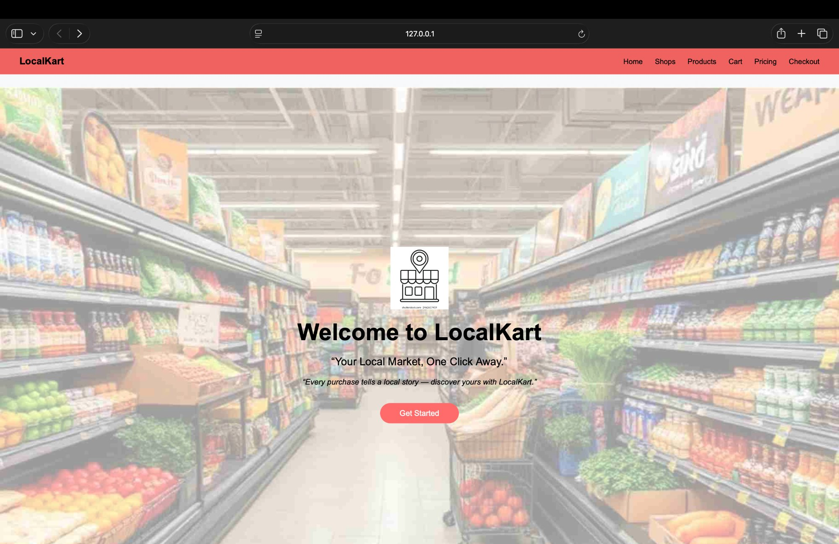

3.2 Login / Register Page (login.html)

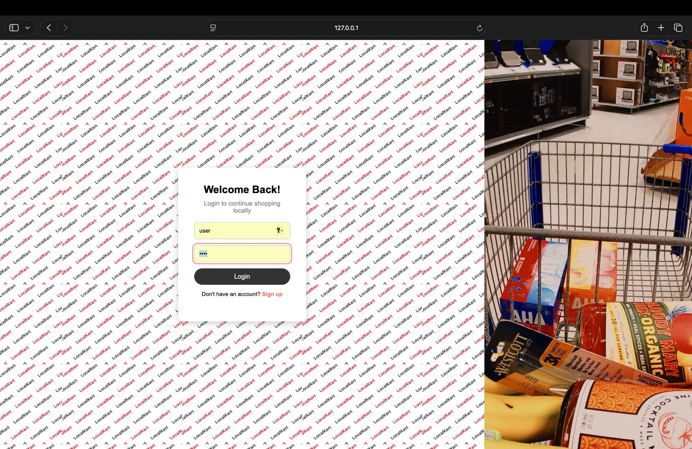

School of  Future Tech |  | 
B.Tech – LocalKart Hyperlocal Marketplace
————————————————————————————————————————————————————————————
3.3 Home Page (home.html)

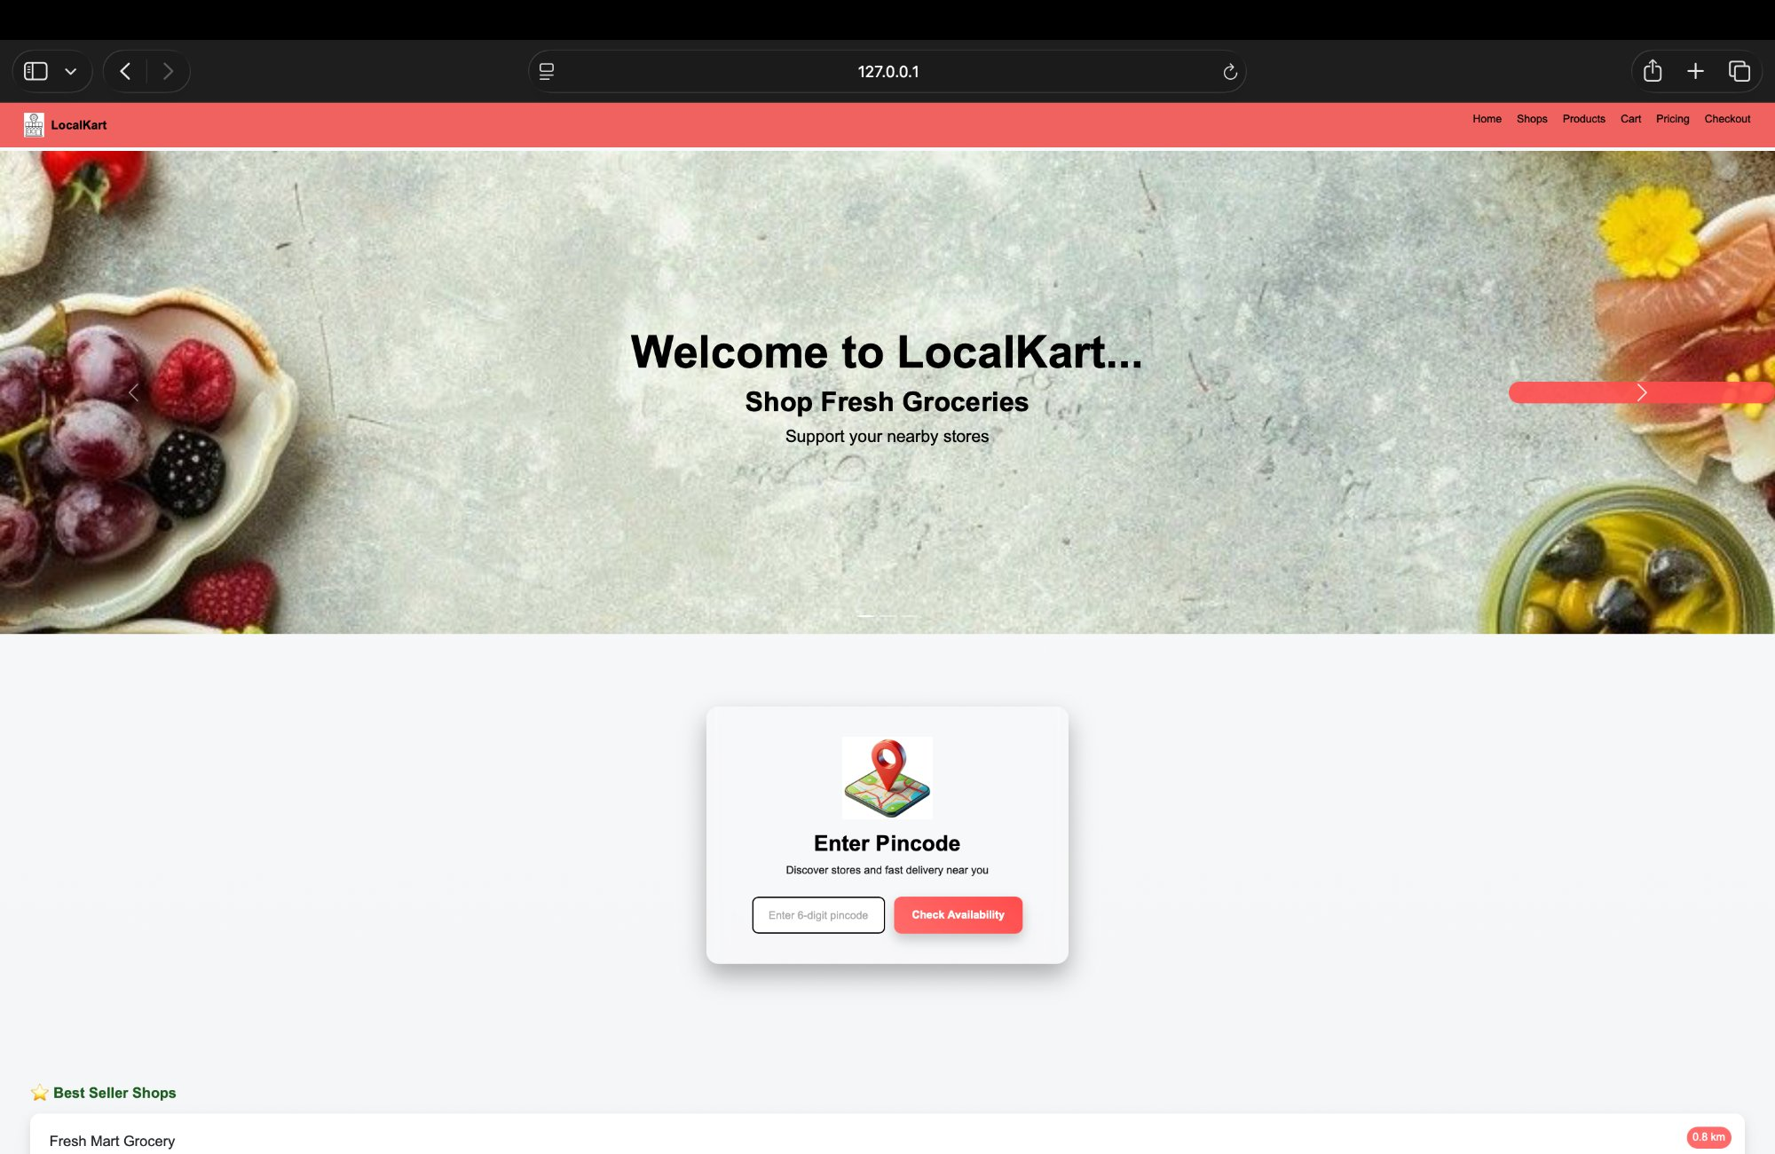

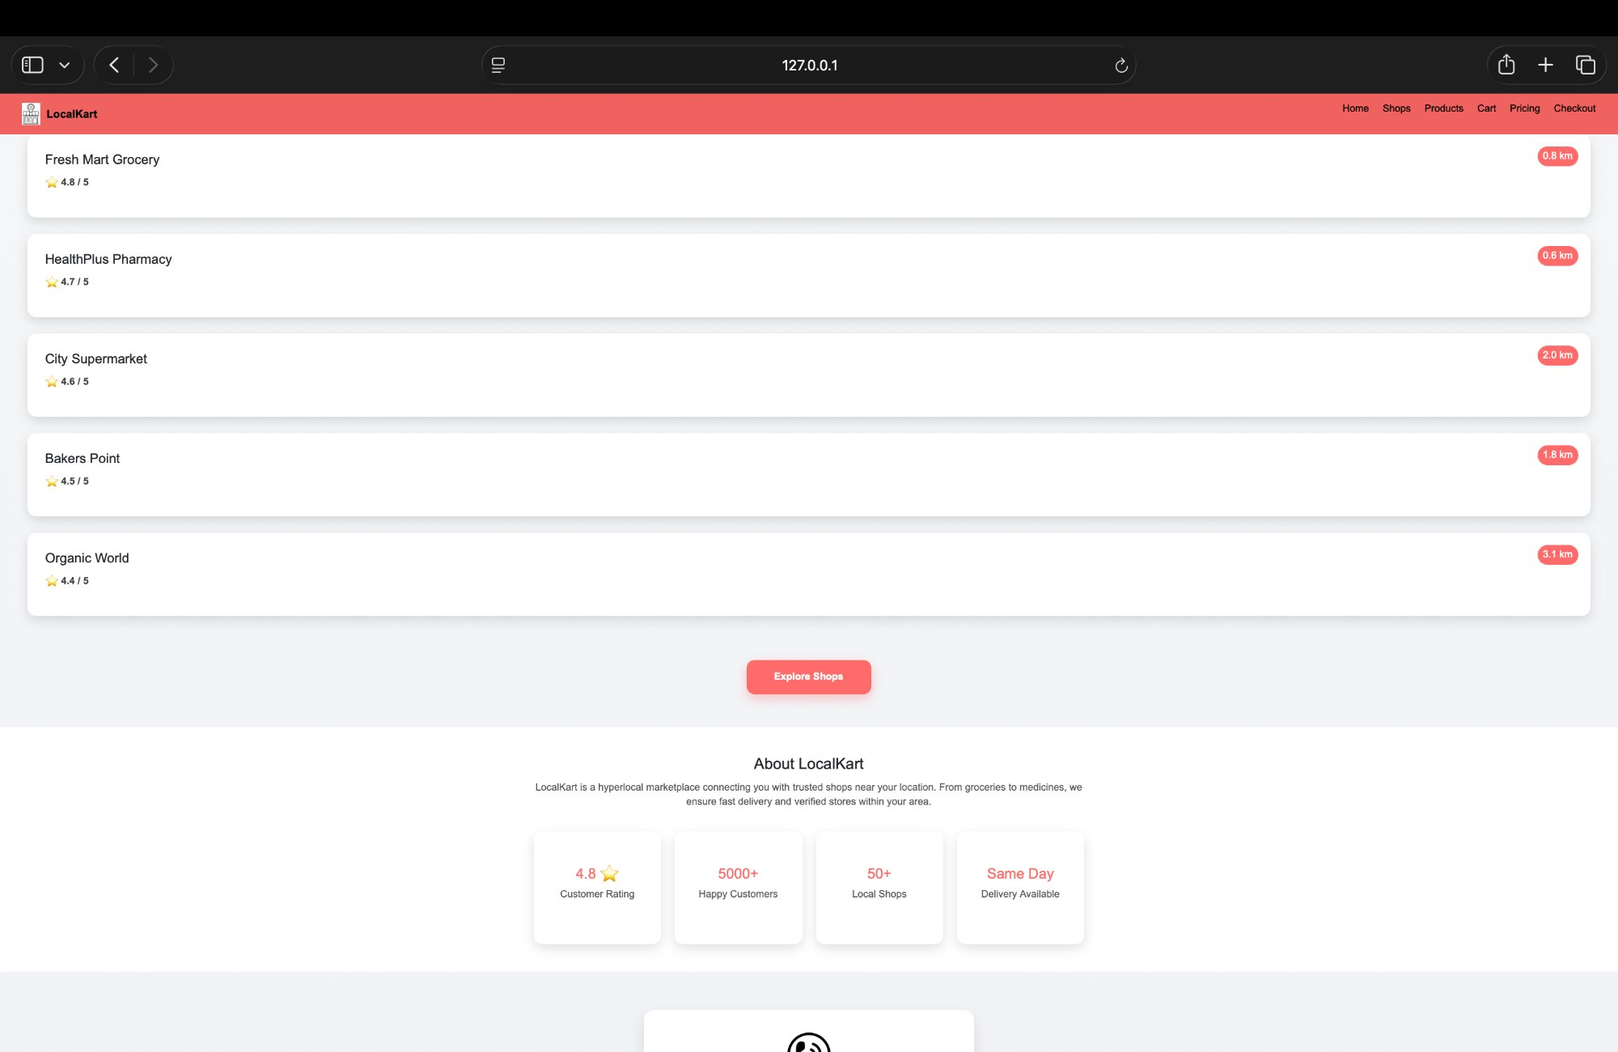

School of  Future Tech |  | 
B.Tech – LocalKart Hyperlocal Marketplace
————————————————————————————————————————————————————————————

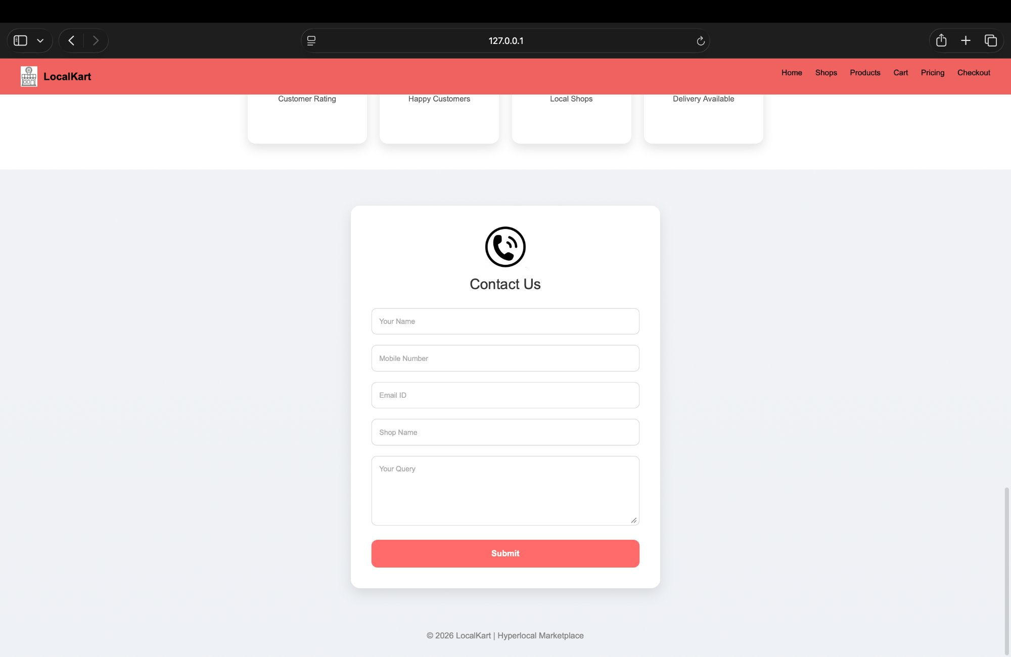

3.4 Shops Page (shops.html)

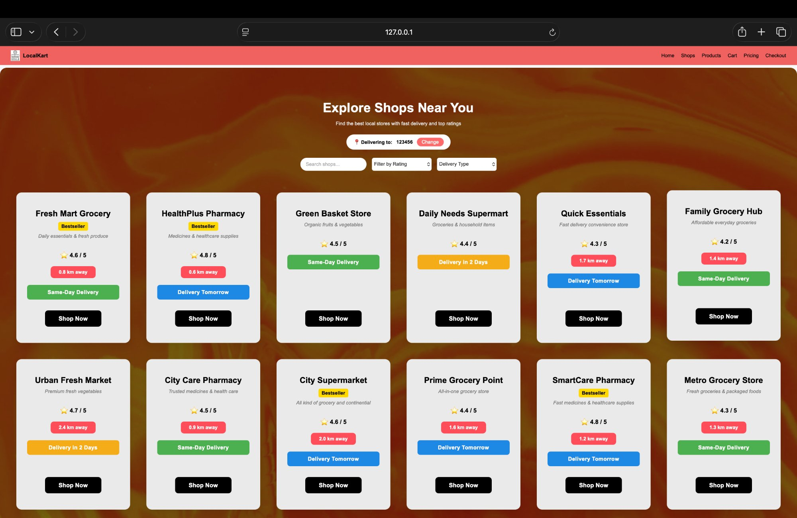

School of  Future Tech |  | 
B.Tech – LocalKart Hyperlocal Marketplace
————————————————————————————————————————————————————————————

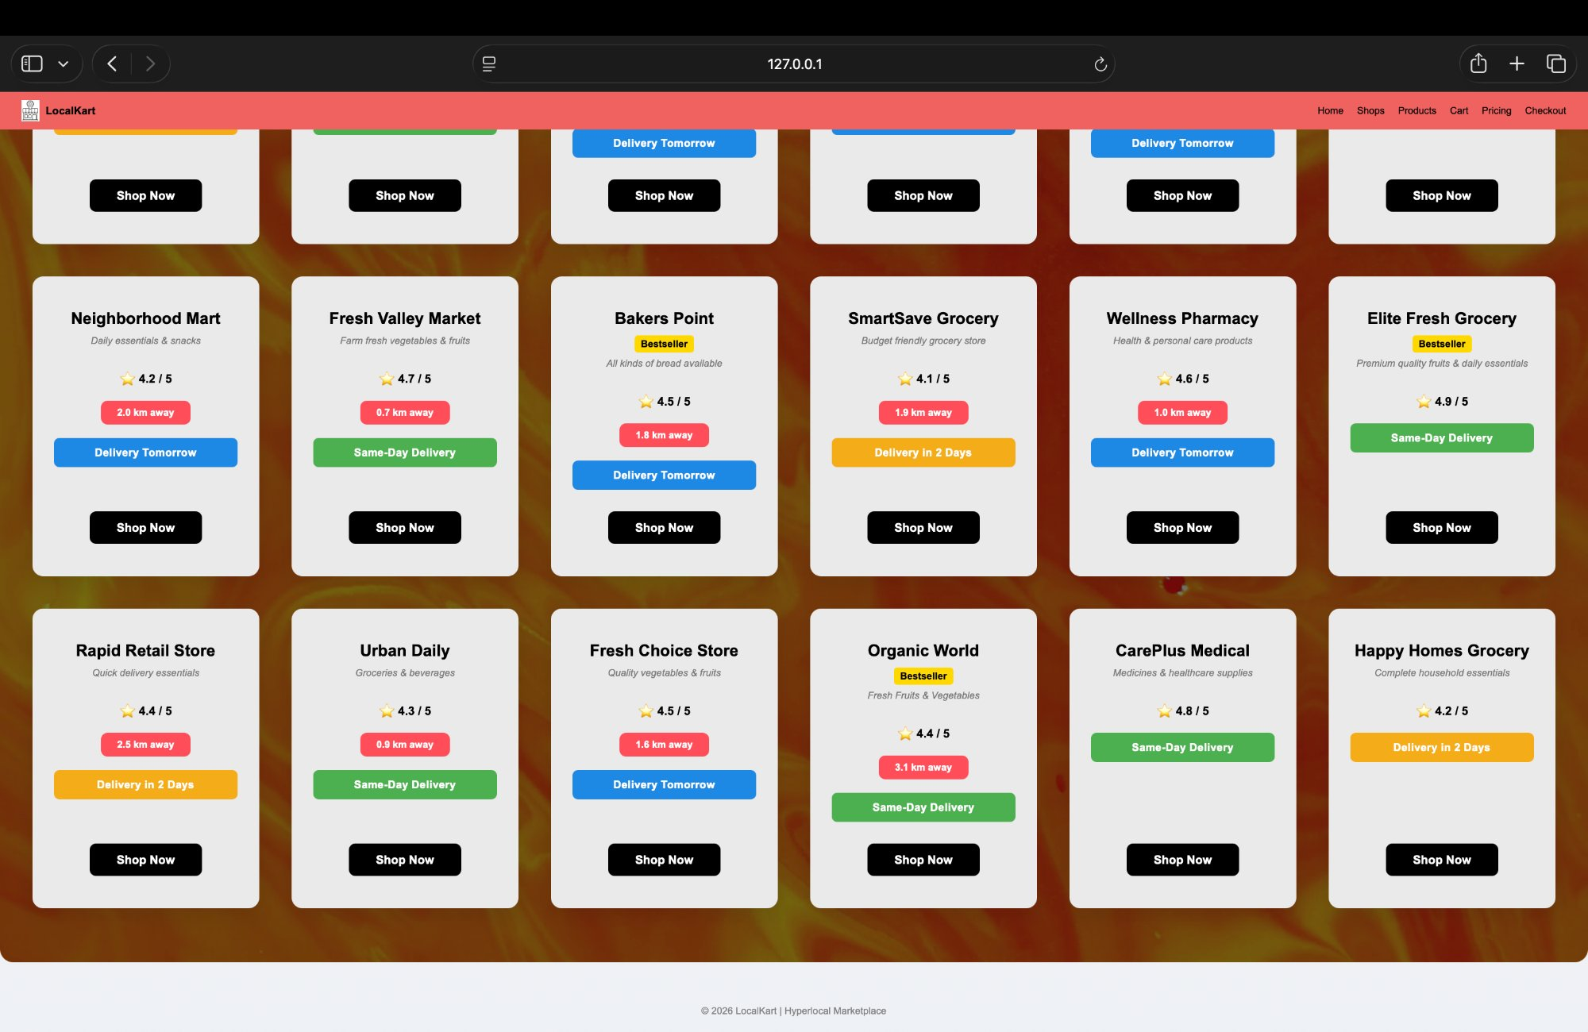

3.5 Products Page (products.html)

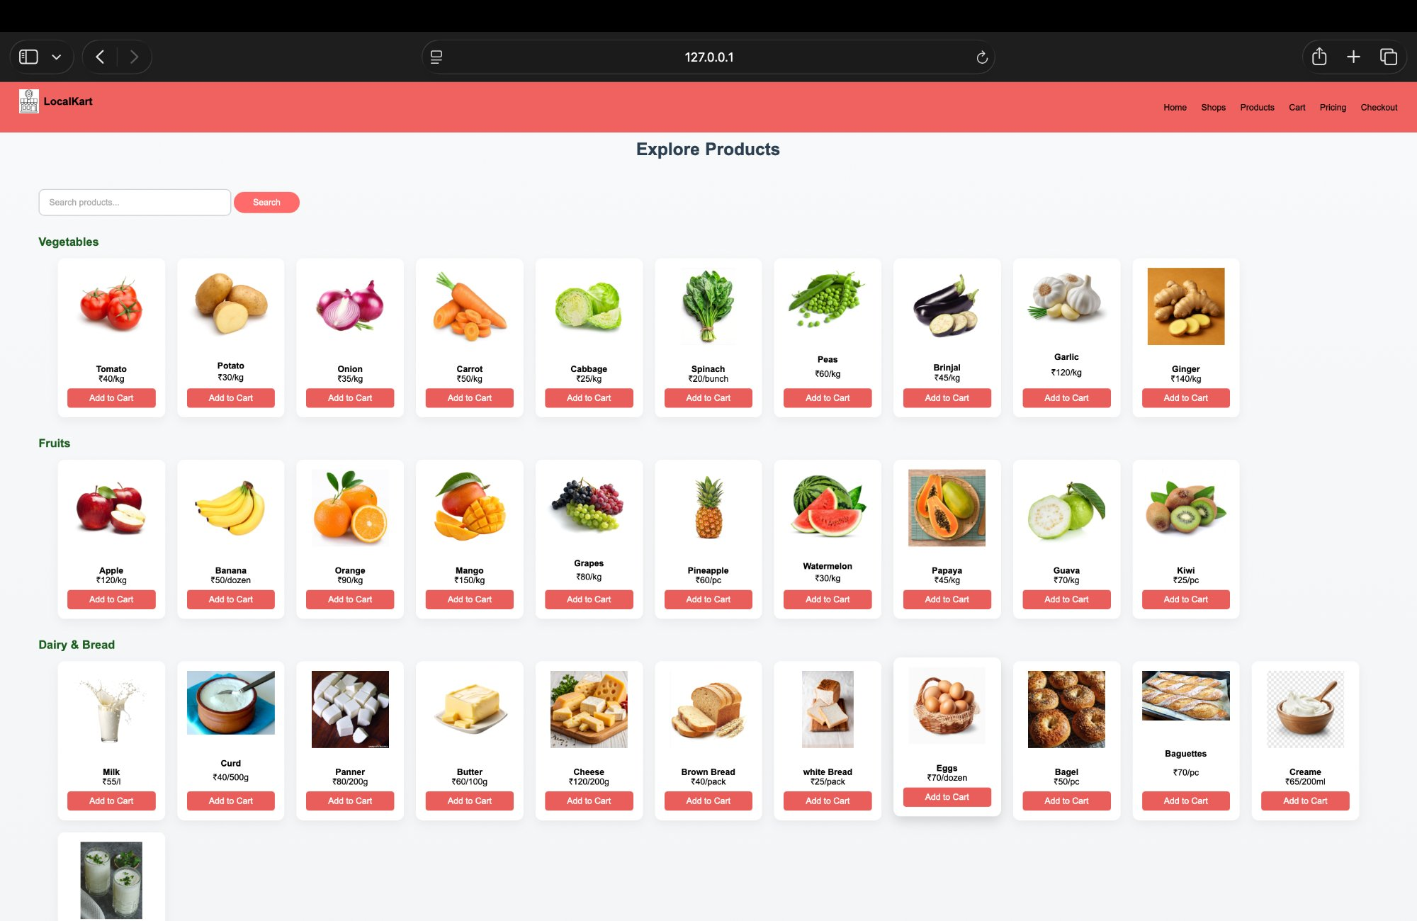

School of  Future Tech |  | 
B.Tech – LocalKart Hyperlocal Marketplace
————————————————————————————————————————————————————————————

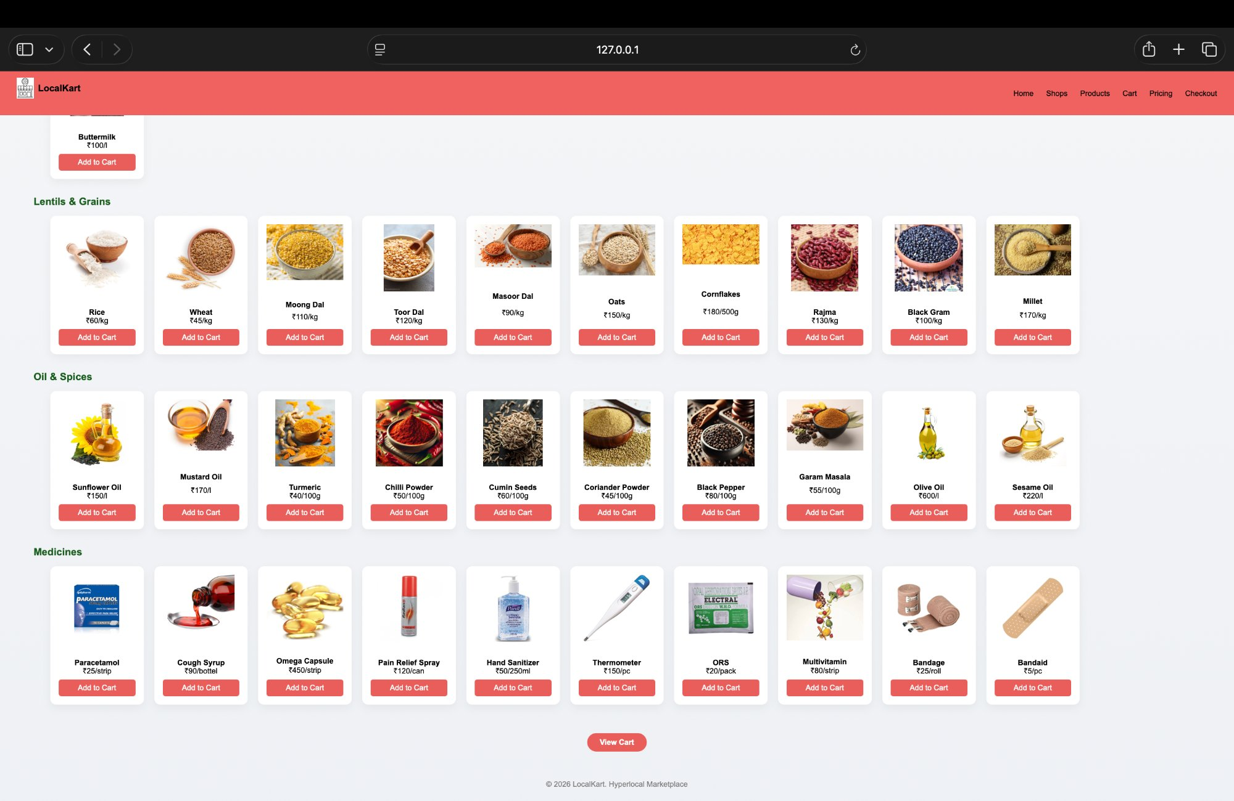

3.6 Cart Page (cart.html)

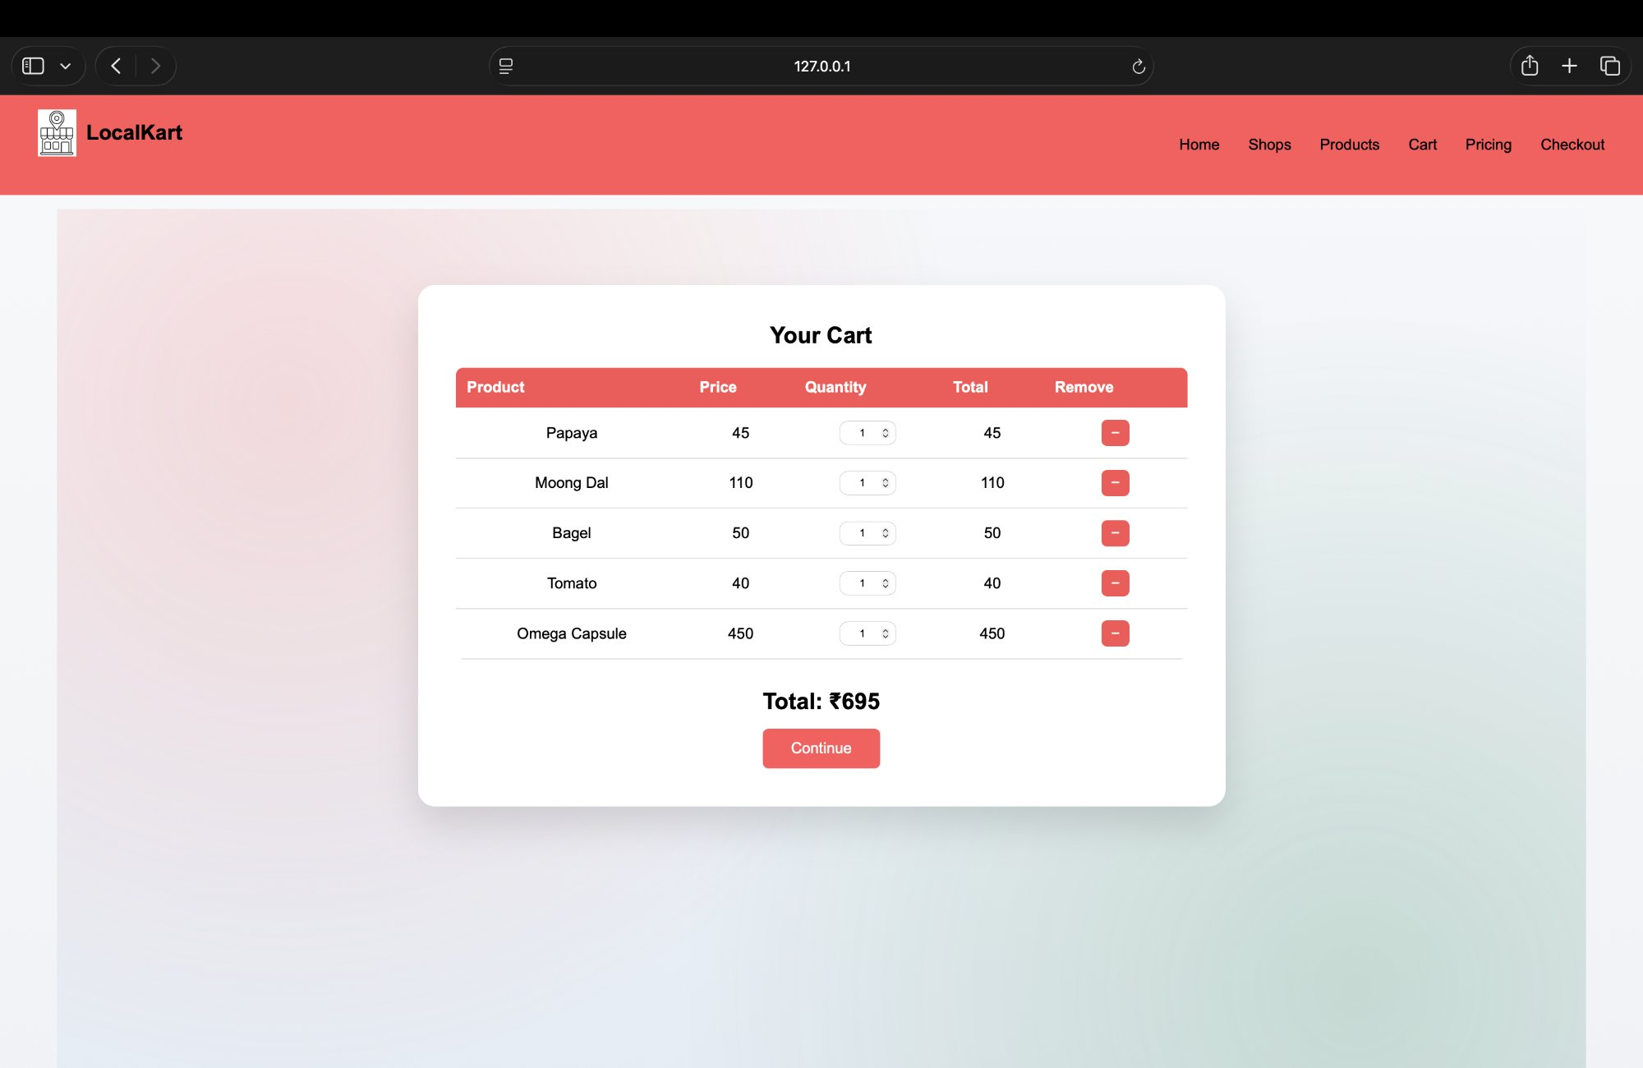

School of  Future Tech |  | 
B.Tech – LocalKart Hyperlocal Marketplace
————————————————————————————————————————————————————————————

3.7 Pricing / Seller Page (pricing.html)

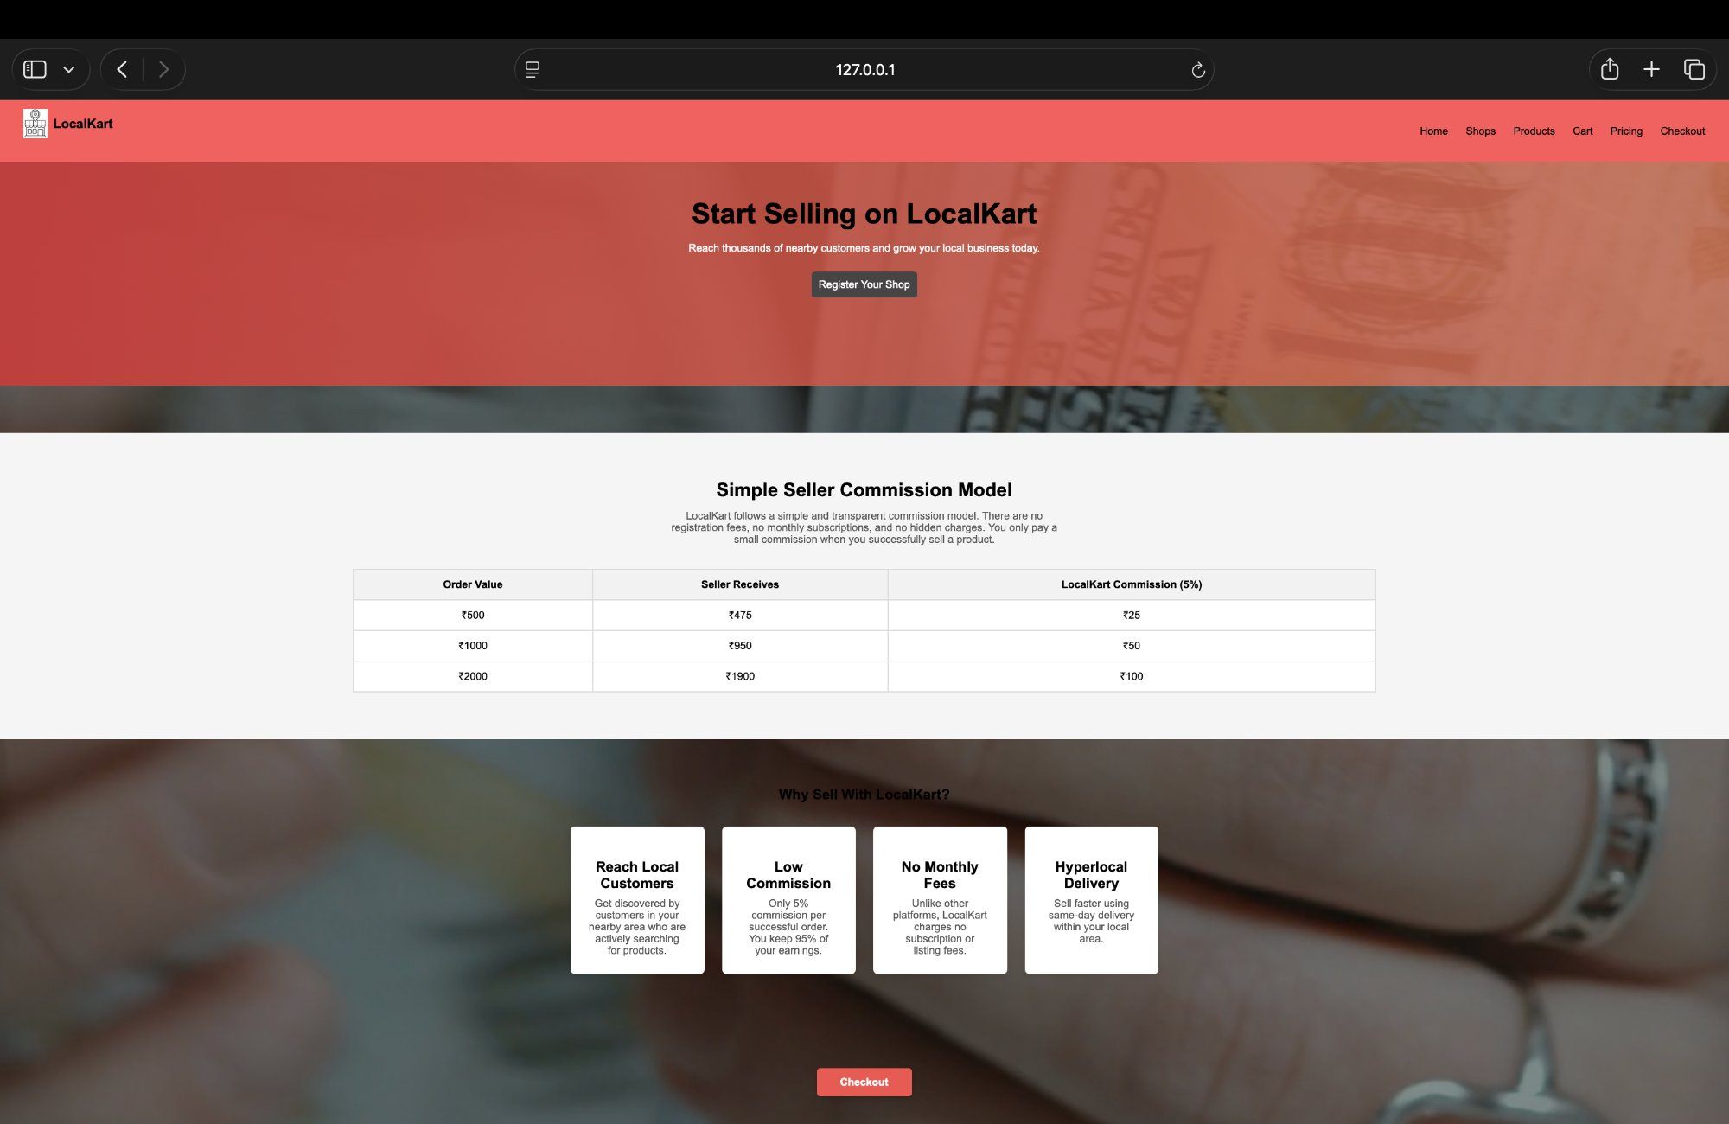

3.8 Checkout Page (checkout.html)

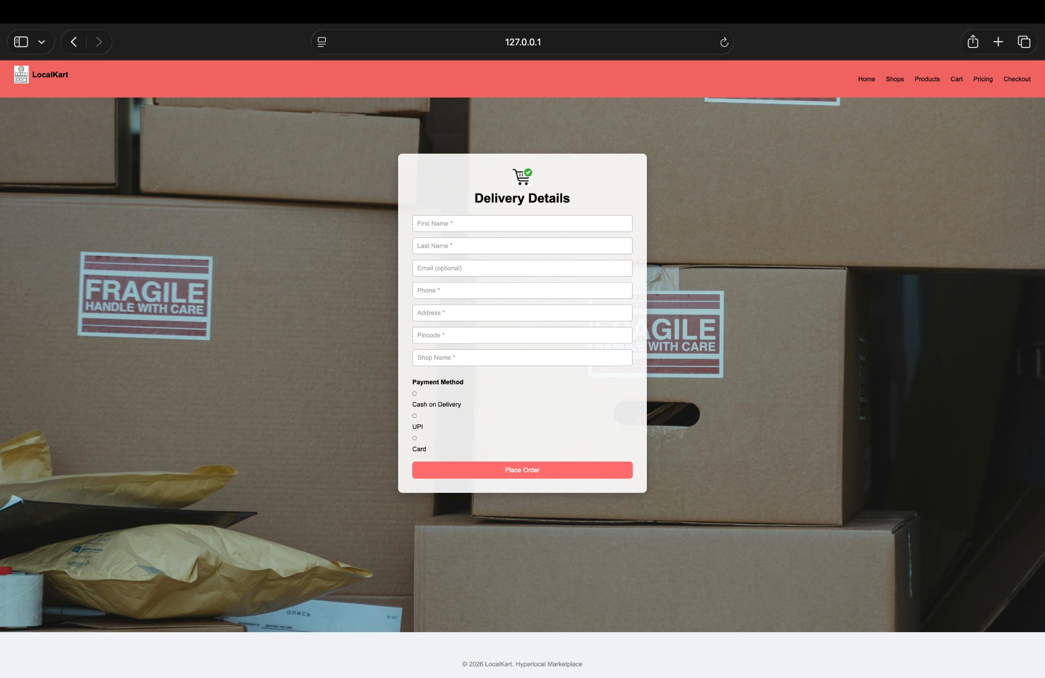

School of  Future Tech |  | 
B.Tech – LocalKart Hyperlocal Marketplace
————————————————————————————————————————————————————————————
4. DECLARATION
I hereby declare that this practical work entitled
"Design and Development of a Hyperlocal Marketplace using HTML 5, CSS 3, and JavaScript"
is my original work carried out by me. This work has not been copied from any source and has not been submitted earlier for any examination.

School of  Future Tech |  | 
B.Tech – LocalKart Hyperlocal Marketplace
————————————————————————————————————————————————————————————
5. FUTURE SCOPE
The current website is developed using HTML 5, CSS 3, JavaScript, and a minimal Node.js backend. The future enhancements that can be implemented are:

- Integrating a real database (MongoDB or MySQL) for persistent product and user data
- Implementing JWT-based authentication for secure login and session management
- Building a dedicated seller dashboard for inventory and order management
- Integrating a real payment gateway (Razorpay / Paytm) for live transactions
- Making the platform a Progressive Web App (PWA) for mobile installation
- Adding real-time order tracking using WebSockets
- Implementing a review and rating system for shops and products
- Enhancing accessibility using ARIA attributes and screen reader support
- Hosting the platform on a live server (AWS / Vercel / Render)
- Applying advanced CSS animations and micro-interactions for better UX

